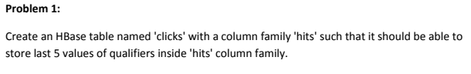

**Solution:-**

First we need to start all the daemons such as yarn daemons and storage (HDFS) daemons by using **start-all.sh**

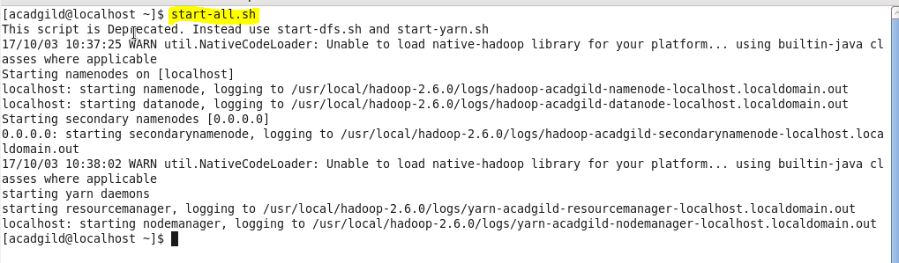

Now we need to start **HMaster** by using start-hbase.sh



Now we have displayed all the started and currently running daemons by using command **jps**.

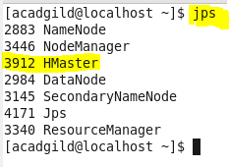

To run on hbase shell, we have given the **“hbase shell”** command.

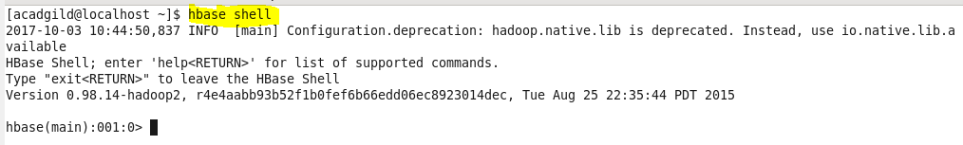

As per the requirement in the question, we have **created the table named ‘clicks’ with column family ‘hits’.**

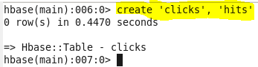

Now we have created the versions for **column family hits as 5. By default, version is 1 for any column family.**

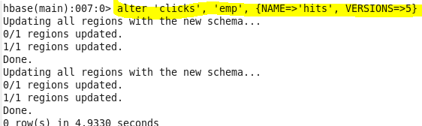

Now we have **inserted the value ‘AB’** for **column “qualifiers**” under the **column family “hits”** for the rowkey **“emp”** in the table **“clicks”**.

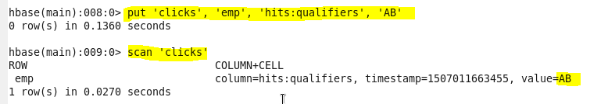

Now we have **inserted the value “Ashok”** for **column “qualifiers**” under the **column family “hits”** for the rowkey **“emp”** in the table **“clicks”**. We have scanned the table named **“clicks”.** You can see that value of column named qualifiers is updated as **“Ashok”.** (Changed from AB to Ashok)

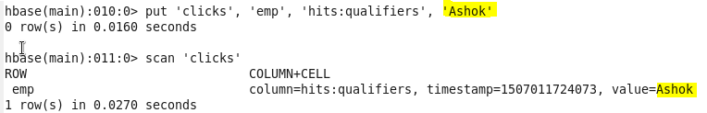

Now we have **inserted the value “Arun”** for **column “qualifiers**” under the **column family “hits”** for the rowkey **“emp”** in the table **“clicks”**. We have scanned the **“clicks”.** You can see that value of column named qualifiers is updated as **“Arun”.** (Changed from Ashok to Arun)

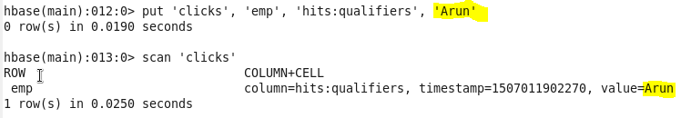

Now we have **inserted the value “Arjun”** for **column “qualifiers**” under the **column family “hits”** for the rowkey **“emp”** in the table **“clicks”**. We have scanned the table **“clicks”.** You can see that value of column named qualifiers is updated as **“Arjun”.** (Changed from Arun to Arjun)

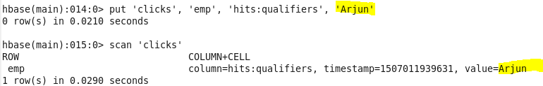

Now we have **inserted the value “Abhinav”** for **column “qualifiers**” under the **column family “hits”** for the rowkey **“emp”** in the table **“clicks”**. We have scanned the table **“clicks”.** You can see that value of column named qualifiers is updated as **“Abhinav”.** (Changed from Arjun to Abhinav)

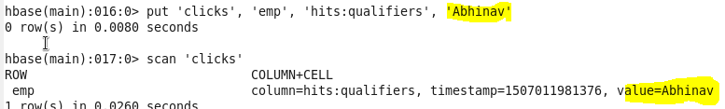

Now using the below **get command**, we got the previously stored 5 qualifiers by giving VERSIONS as 5. If you give VERSIONS as 3, then you see the previously stored 3 qualifiers.

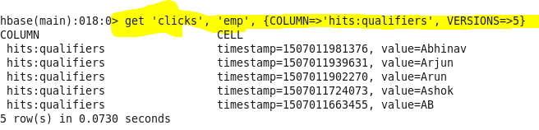

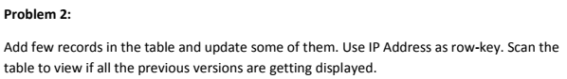

**Explanation:-**

Now we have **added few records for rowkey “IP Address” in table “clicks”.** 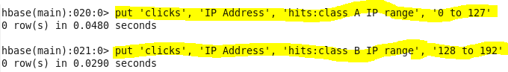

We have scanned the table named “clicks”. Its **showing as 2 rows because there are 2 rowkeys** such as “IP Address” and “emp”.

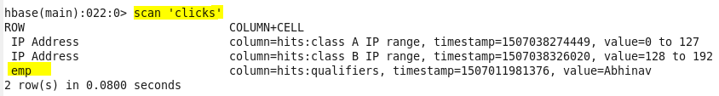

Now we have **updated** the value for column “Class B IP Address” **from “128 to 192” to “128 to 191”**



Scanned the value of table **“clicks”** in that you can see the updated value for column “Class B IP Address”**.**

